Contents

Class 10: SharePoint Permissions 1

We create posts Under Blog Not Lists 4

Opinions 4

Categoty 4

Project 5

1.Hide 10

2.How can we add an introduction for an item 13

Logo 18

3.how to hidden: Budjet From the following form 19

Permission 21

Grant Permission 22

Permission Levels 23

Summary for permition 36

# Class 10: SharePoint Permissions

Query String: If you put User name Password, it is not secured.

AS we know we have Two Pages

1. Web Part Pages
2. Wiki Part Pages

Open Home Page => Setting => Edite Page => Add a Web Part on the page => click our Promoted Link List

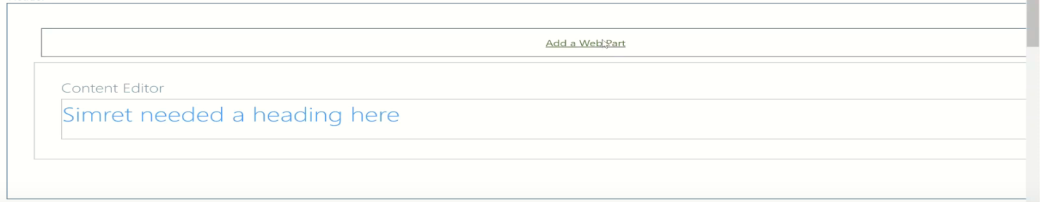

Then we get

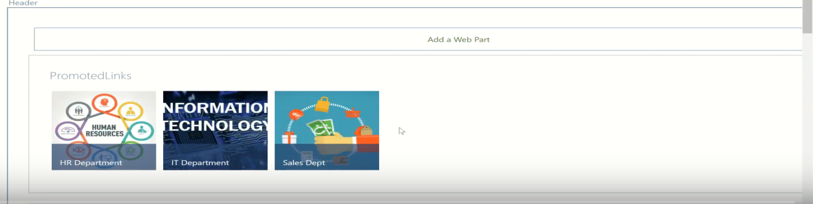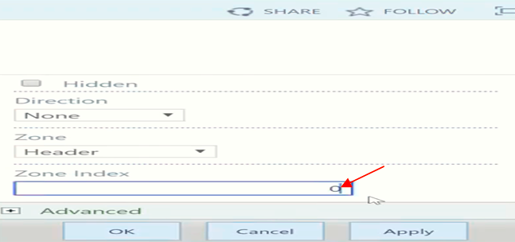

* **To remove It**: Drop down arrow =>Edit => layout => the make **0** the index zone to hiden the second
* **Under appearance: ChromeType (None)**

**Title = Usefule Links**

* Under site setting: change Title , Logo, ….
* When we edit the page the parents are not changed. Eg if we changed Look , Logo , Header, …

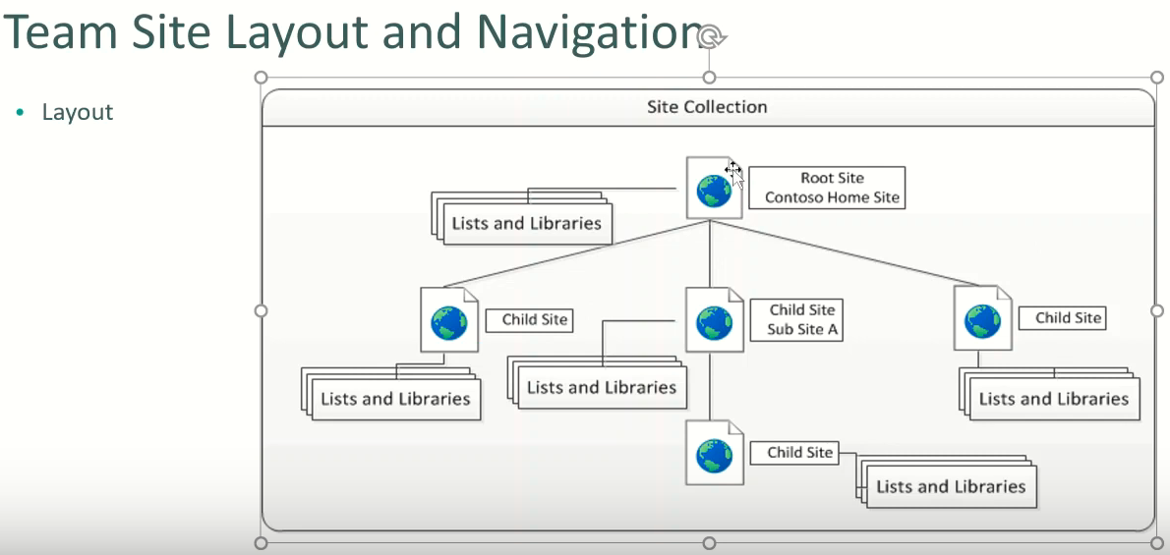

Blog Site:



**From the above URL:**

Blog is the subsite of Demo5

The default.aspx is the default value in the blog page.

**Our Promoted Link List:**

it doesn’t have Edit a page

To create a post: We use

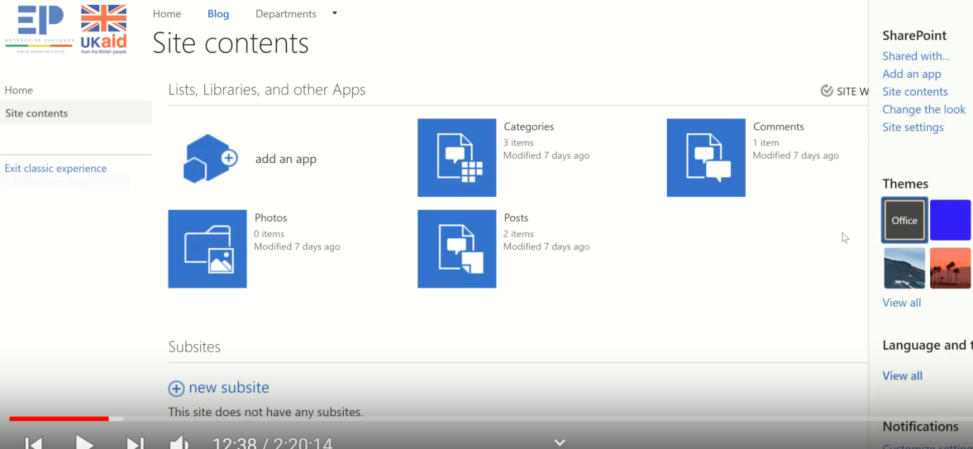

**Or**

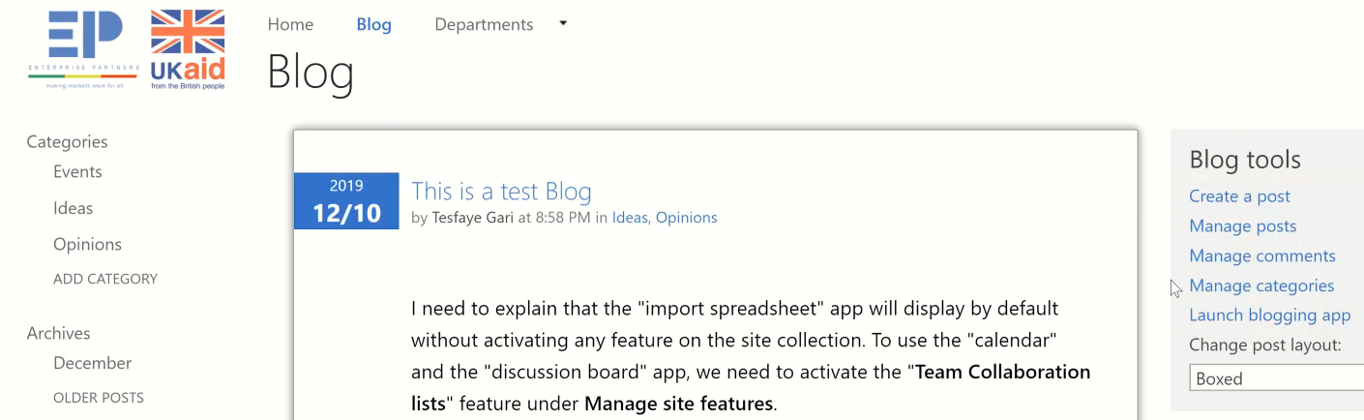

## We create posts Under Blog Not Lists

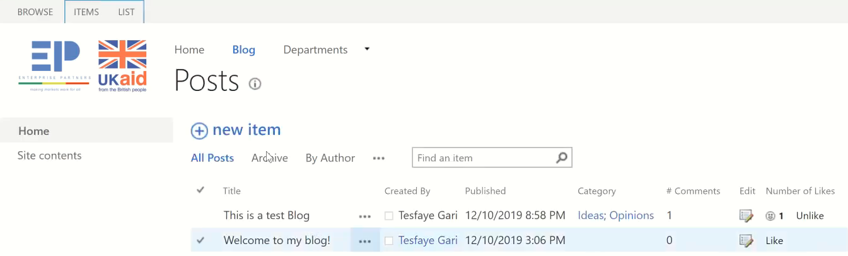

Opinions**: URL?CategoryId= 2, which is Query String & Ideas : CategoryId= 1**

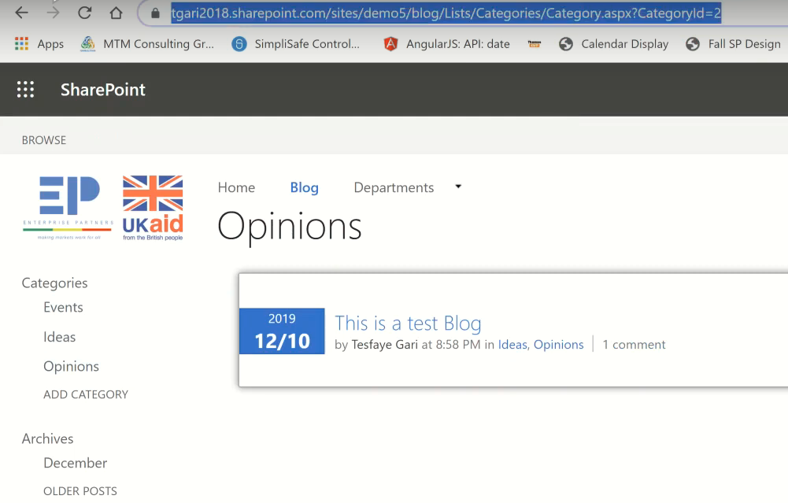

Categoty**: Under Blog ,** Setting => site content =>Category



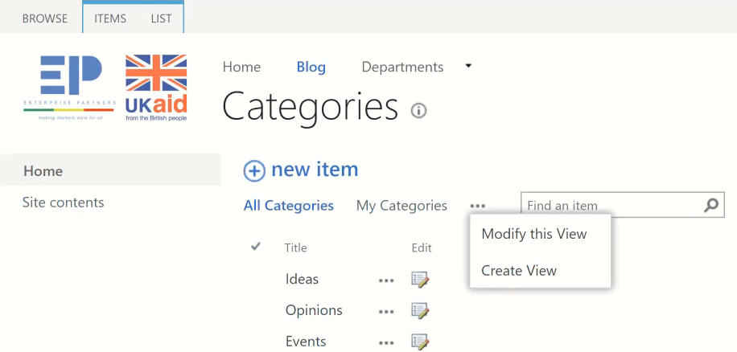

### Project

**Holiday Shopping List:** Name(MyHolidayShopping)

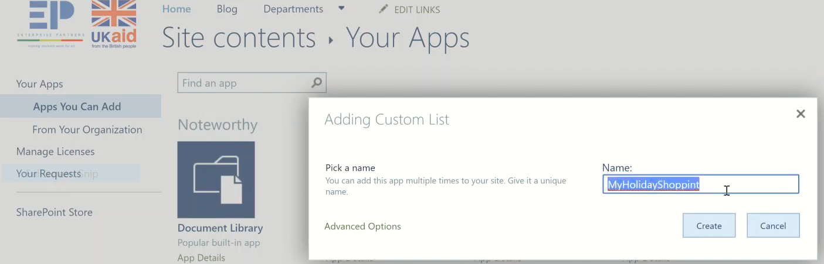

**Open it**

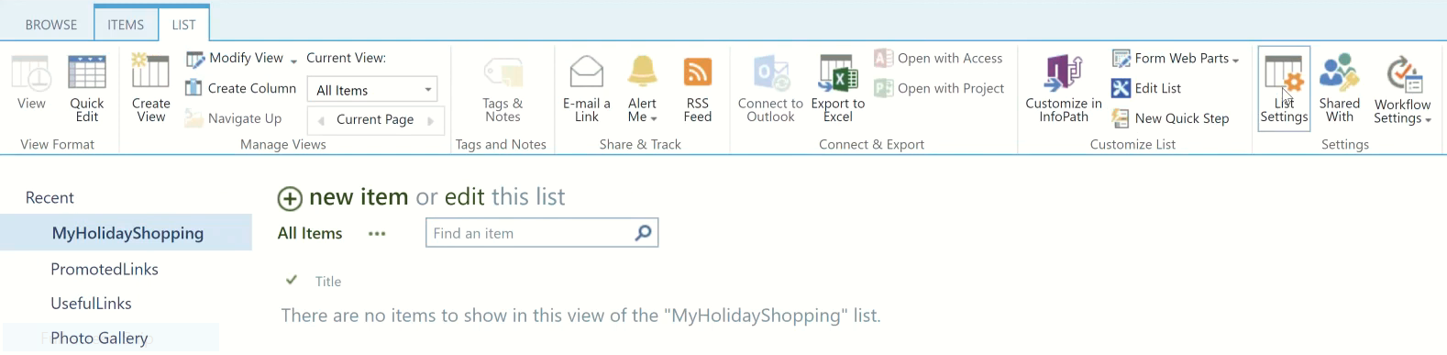

**List => List Setting =>**

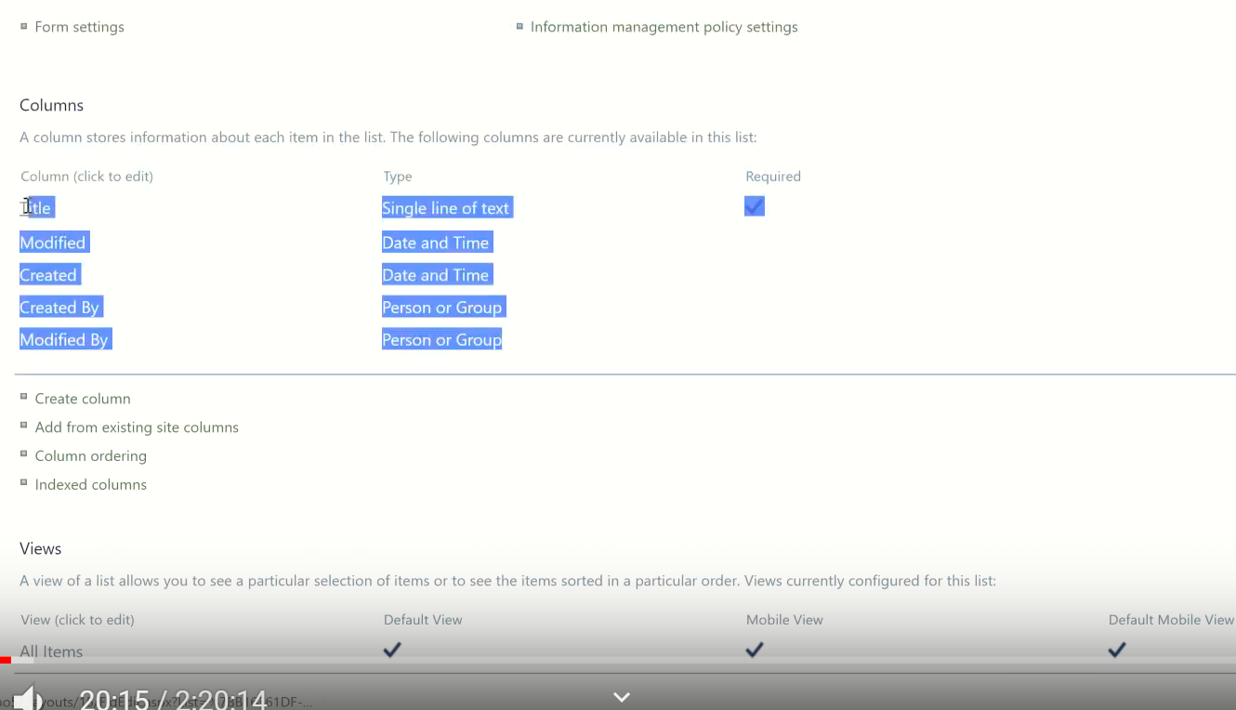

* Change **Title** to Name
* Create: column1: =>Name( Category);Select **Choice**

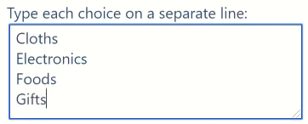

* Create: column2: => Name(Description); **Multiline of Text** and

Select **Plain Text**

* Turn on **Classic Experience** and **Dialog** Under Advanced Setting

**Adding an Item on My HolidayList**

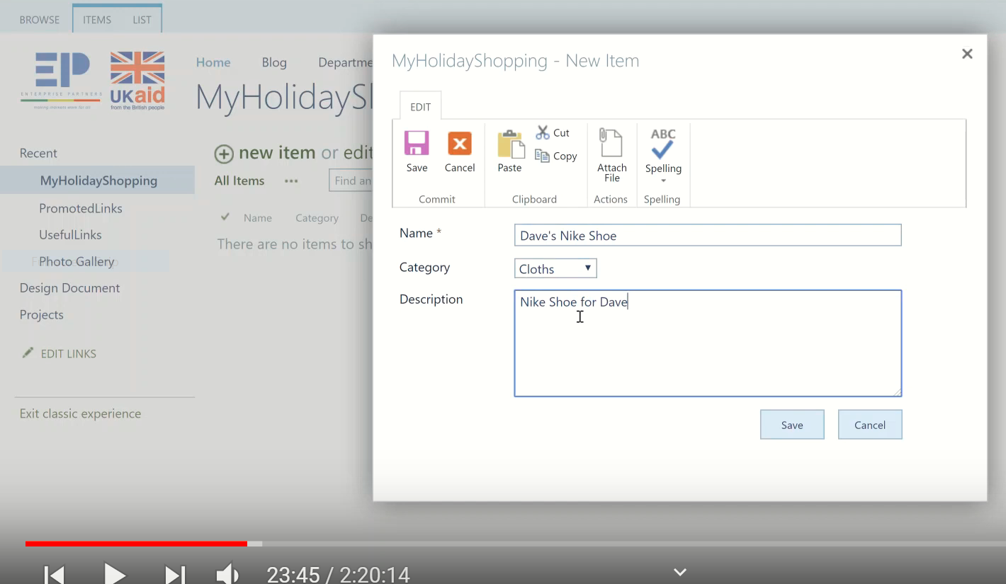

To Edit The Item: Ellipse => Edit

Look the URL



From this we: **Lists** then Our **List Name** and the a **view**

**To Create a Colum:**

List => Create Column => Name (MaxBudget) => Select Currency

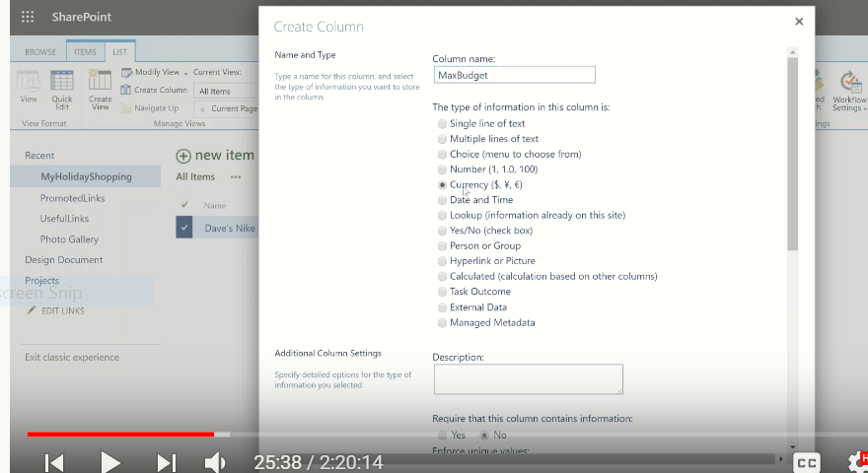

**But I don’t want to show Budget on Item**

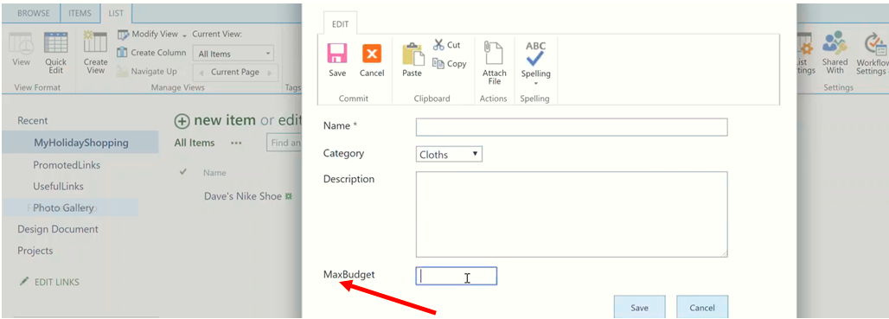

**Column Ordering: lIst => List Setting => Column Ordering =>**

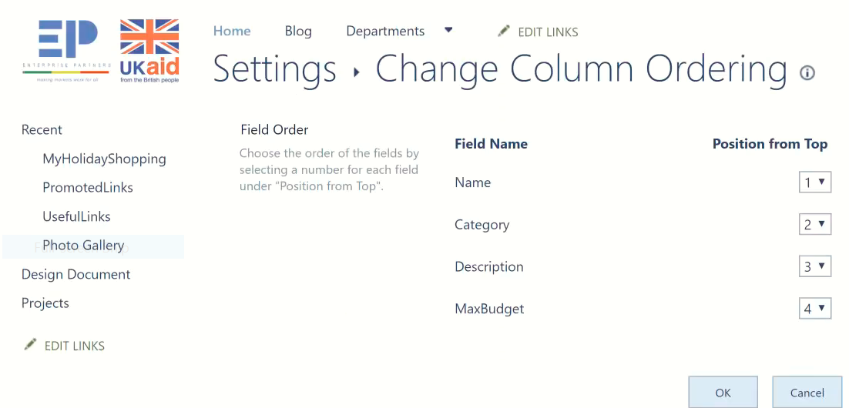

**Content Type:** By default it is turnd off so we need Turn on Under Advanced setting

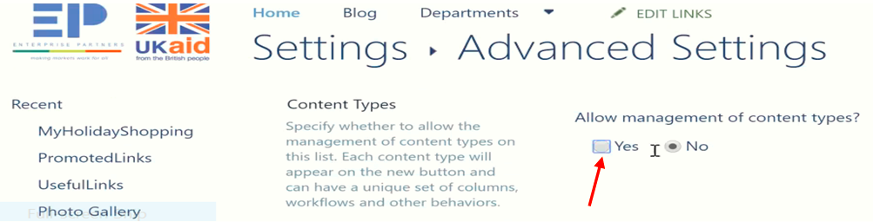

**Then we get:**

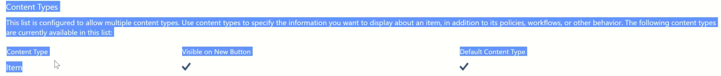

**NB**: **Content Type, Dialog, Classic Experience** … are we found under this setting

Under Content Type: We have only Single content Type **Item**. When we click on it we get

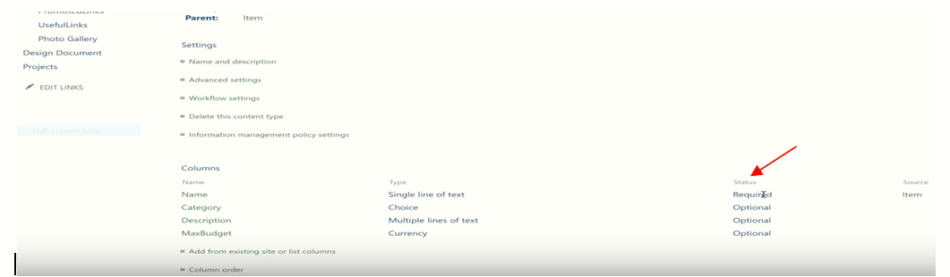

The Status says **required** or Optional

### 1.Hide

If we click on Budget

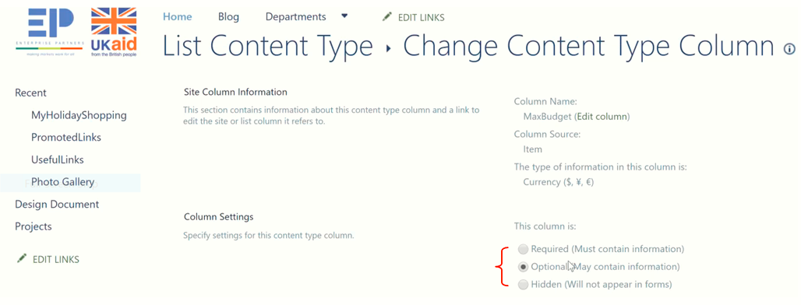So Change the above **Optional** to **Hidden** So we get

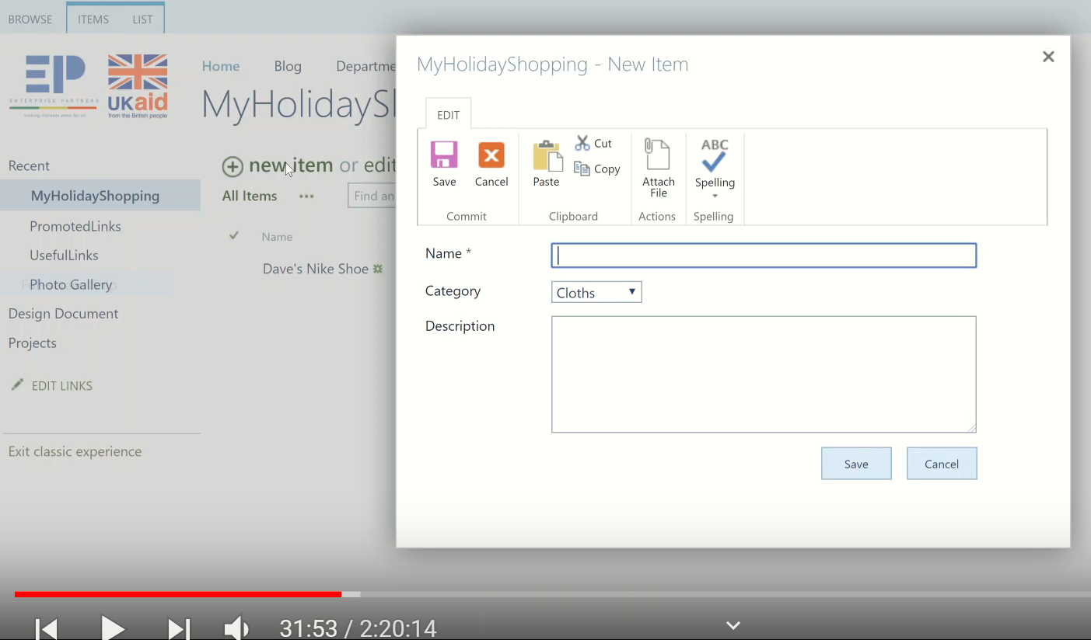

Can we do Instead of **Save = submit** and instead of **cancel = close?**We can’t in this portion.

Create a View (Data Sheet View)

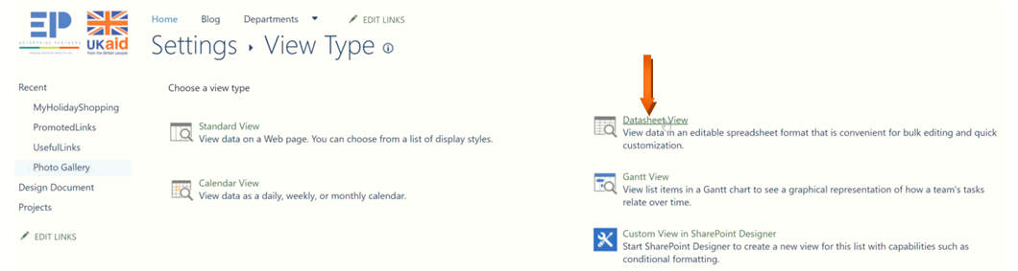

**Then We get the following form and we have to give name(EditItems)**

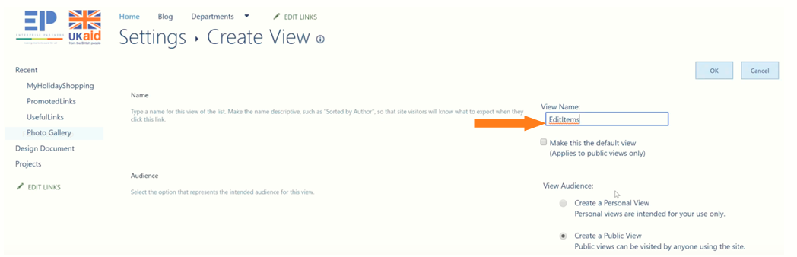

**Then we get this view and then we can add items**

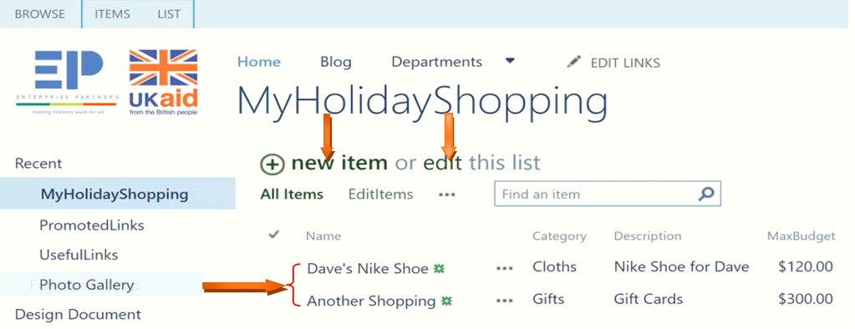

**As we see above there are 3 Forms**

1. New Forms
2. Edit Forms
3. Display Forms

**Customizing List**

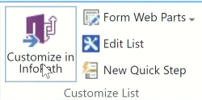

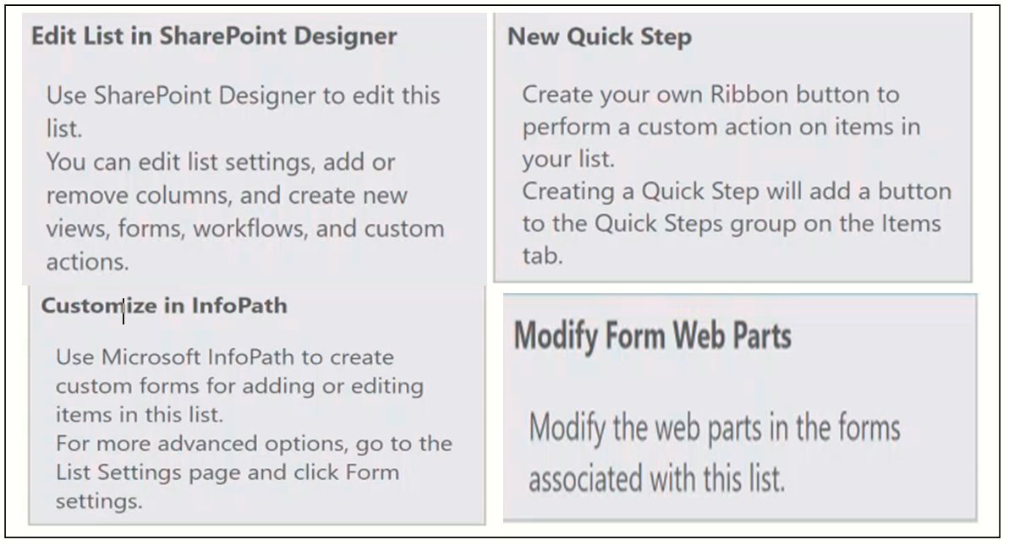

**To add some instructions on the top of item**

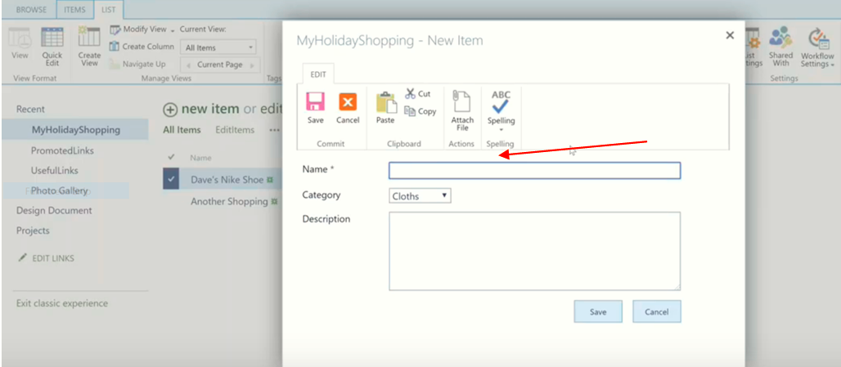

**First Create the List:**

**Under home page open the project**

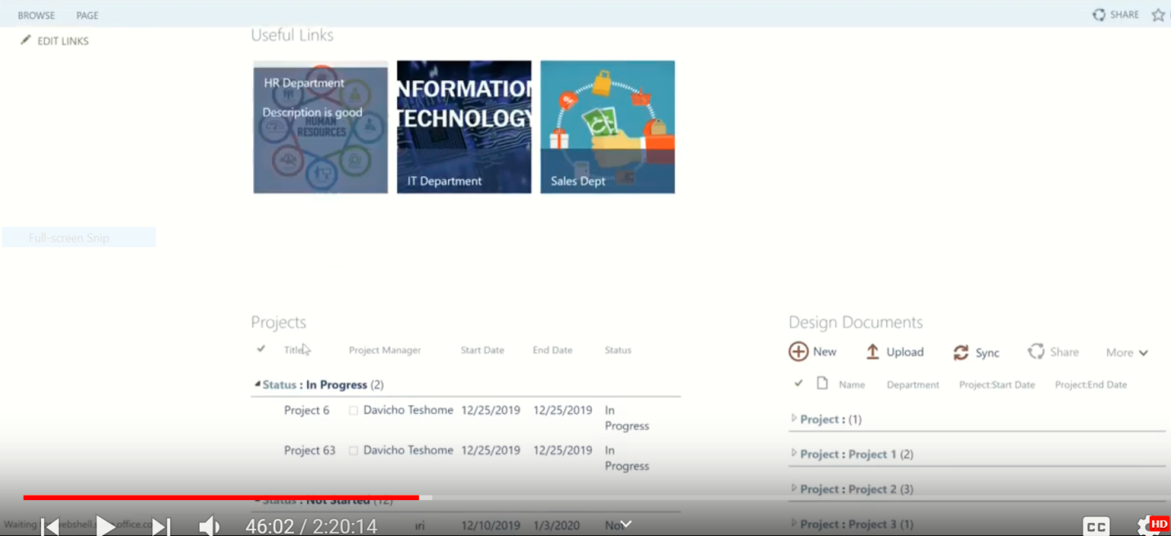

**Setting => Edit page =>**

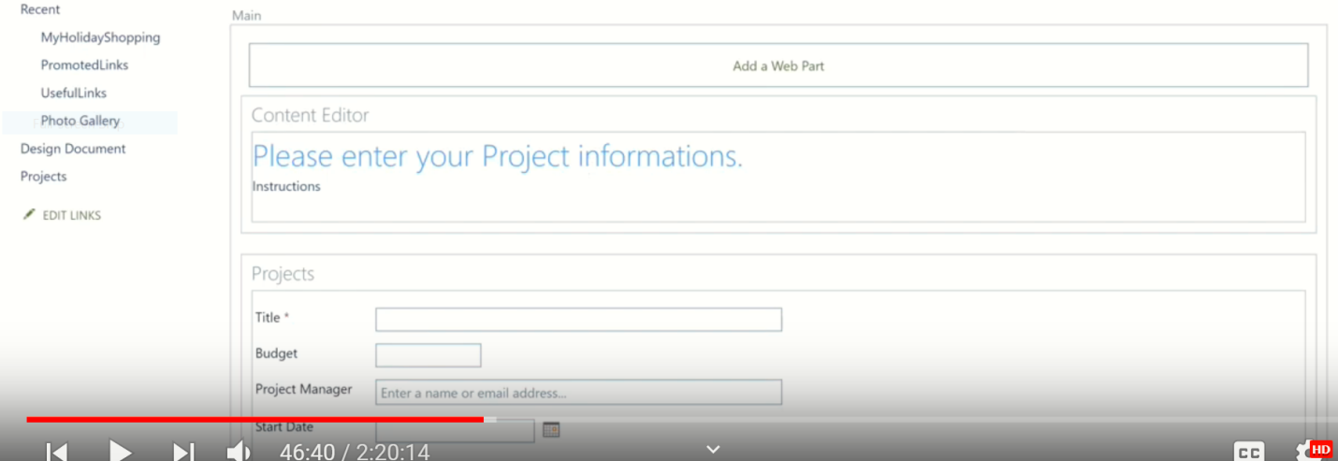

**But this is the for home page.**

2.How can we add an introduction for an item**?**

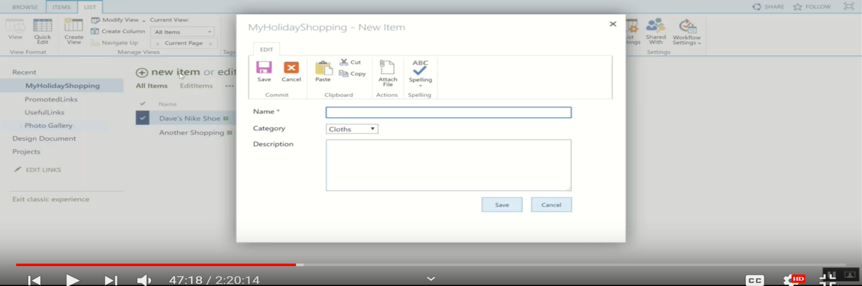

**In this scenario we can’t do on setting: b/se it is pop up so**

**Case 1: Long way**

**Go to Advanced setting make No Dialog check box**

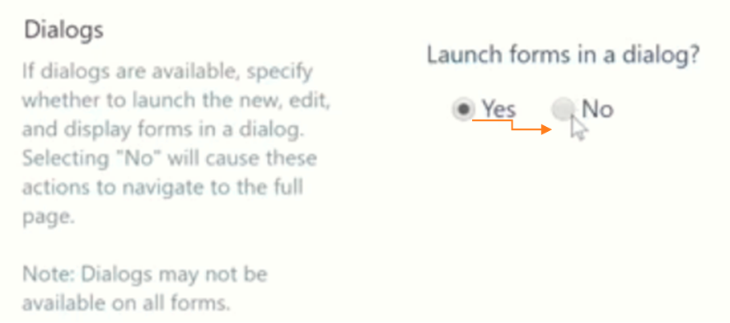

**Case 2: Short way**

**Right click on New item =>open new tab =>then we get the following page with active setting**

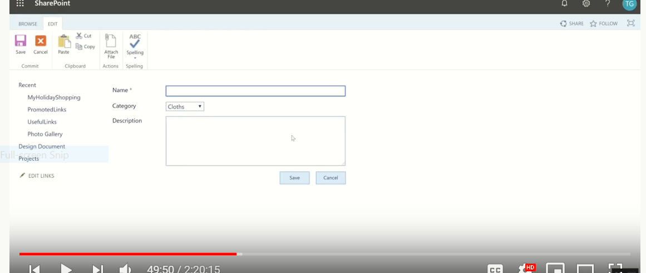

**Then Setting =>Edit page**

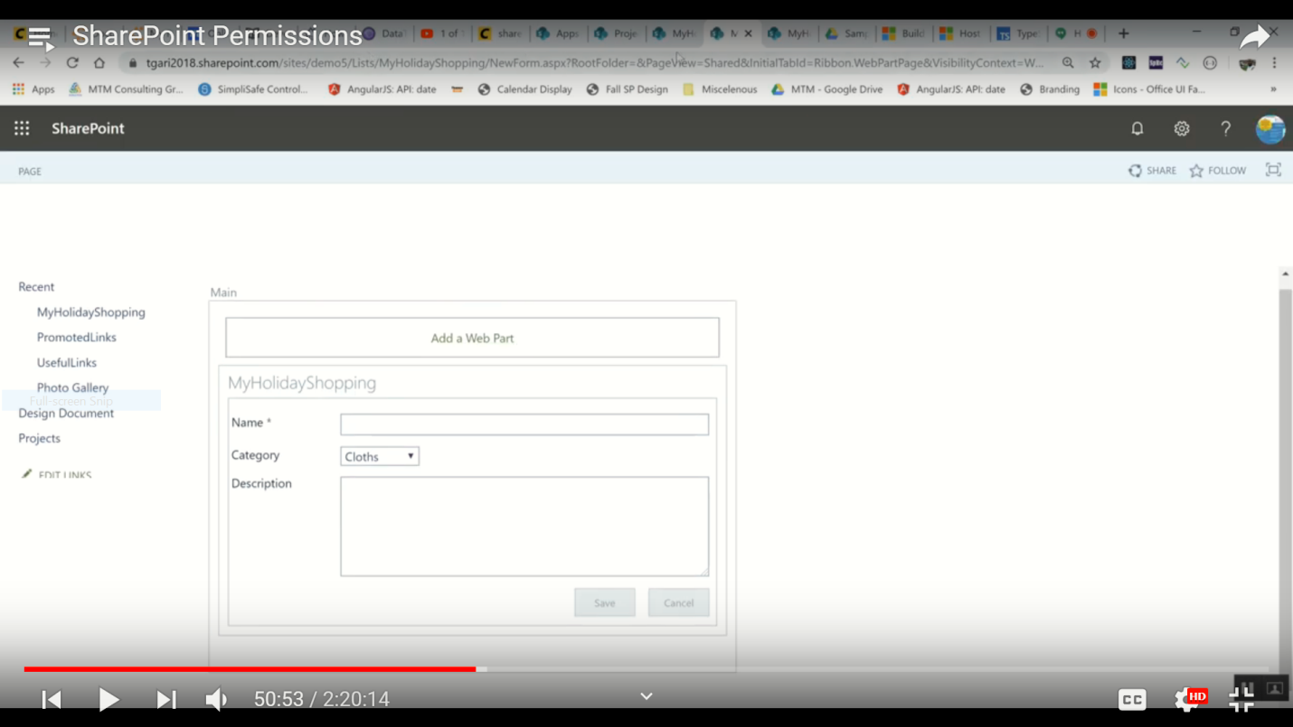

**Then Edit/ add an instruction on this page.**

**Case 3: The most shortest way**

**List => Form(default New Form) =>**

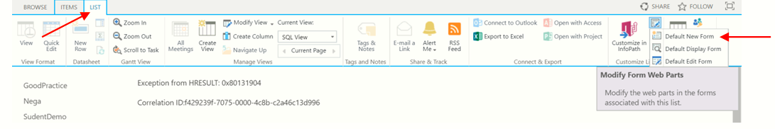

**Then Setting =>Edit page**

**Use the following for all steps**

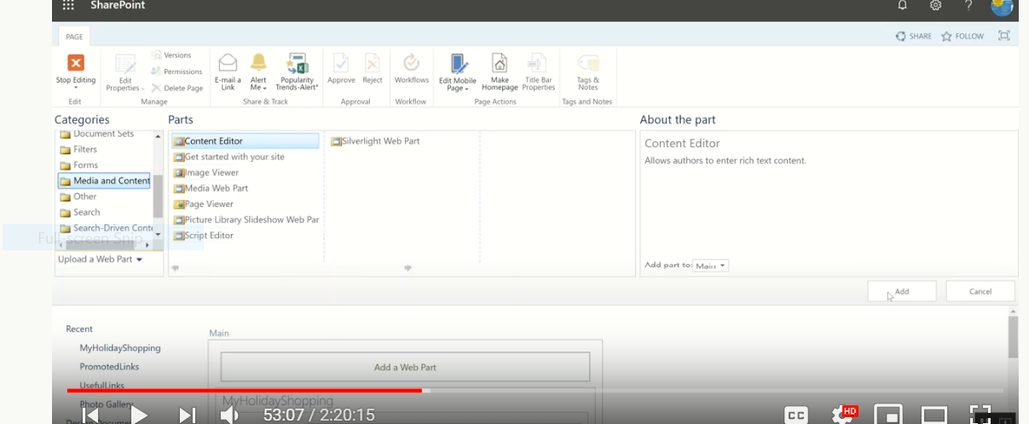

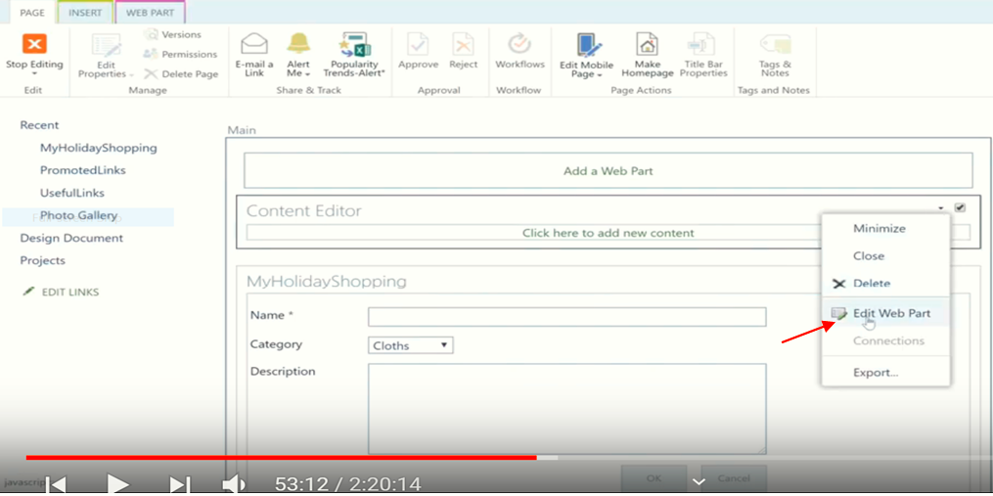

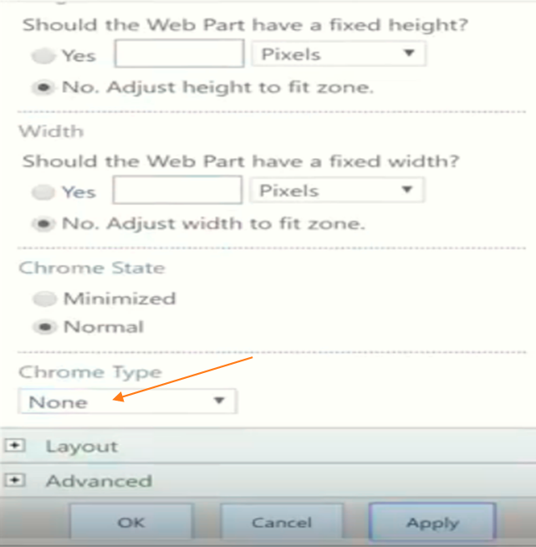

**Then we add an instruction as follow**

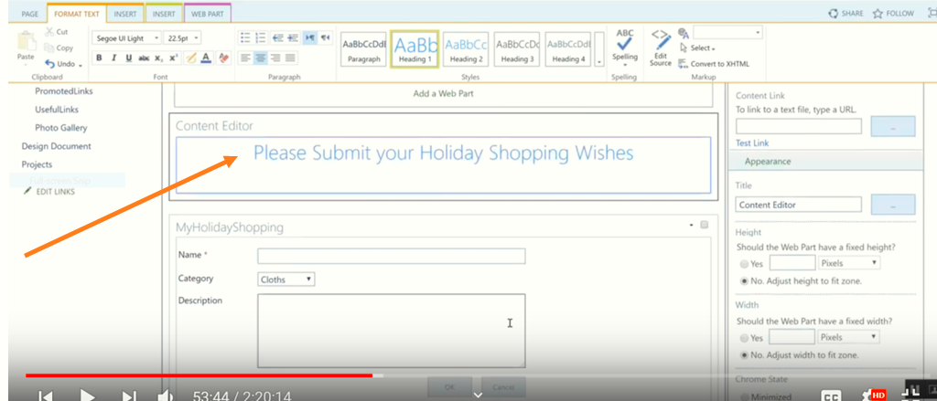

**Then we get**

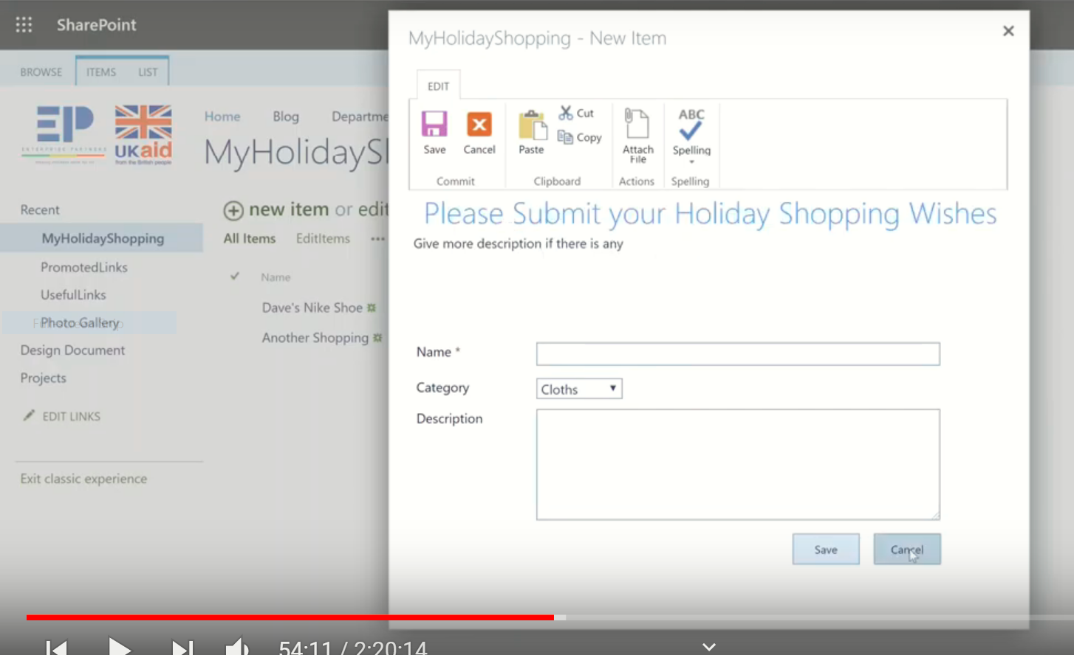

Logo**:**

**List => Form(default New Form) => put the cursor before the title =>Insert => picture =>From(Address of SP)**

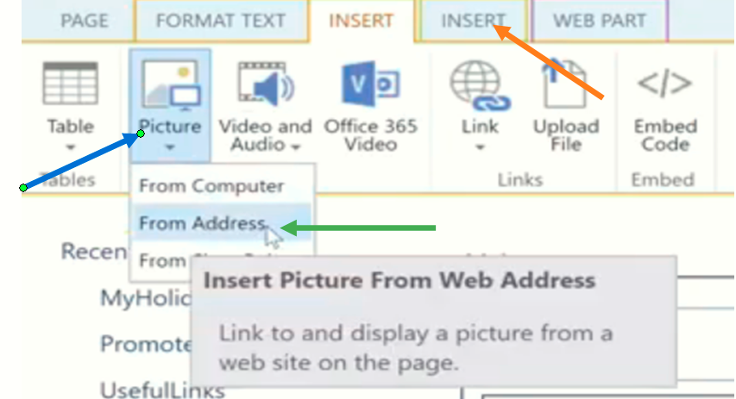

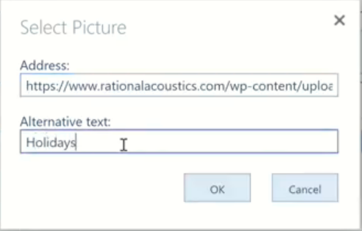

**Then adjust the size and position**

**Then the item forms**

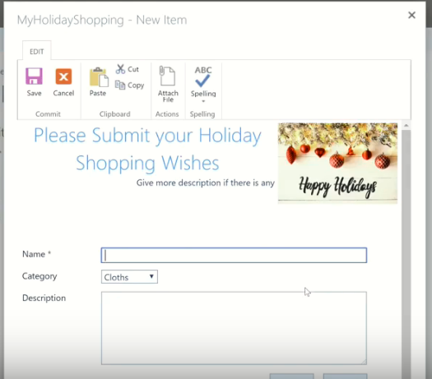

### 3.how to hidden: Budjet From the following form

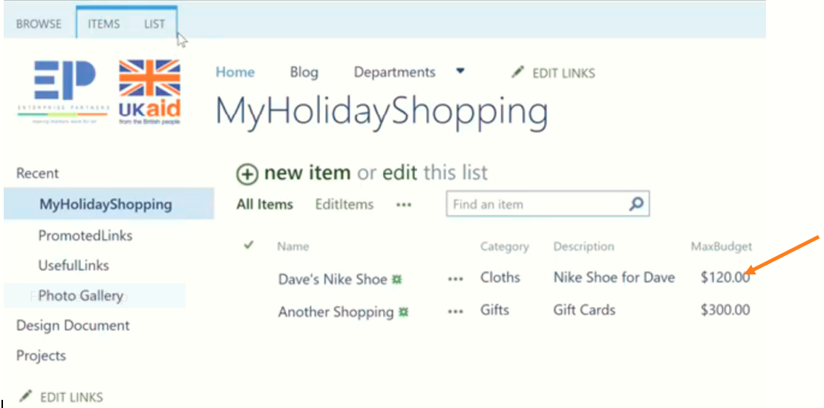

**List =>List setting =>Item =>MaxBudjet => then change Site column from hidden to optional**

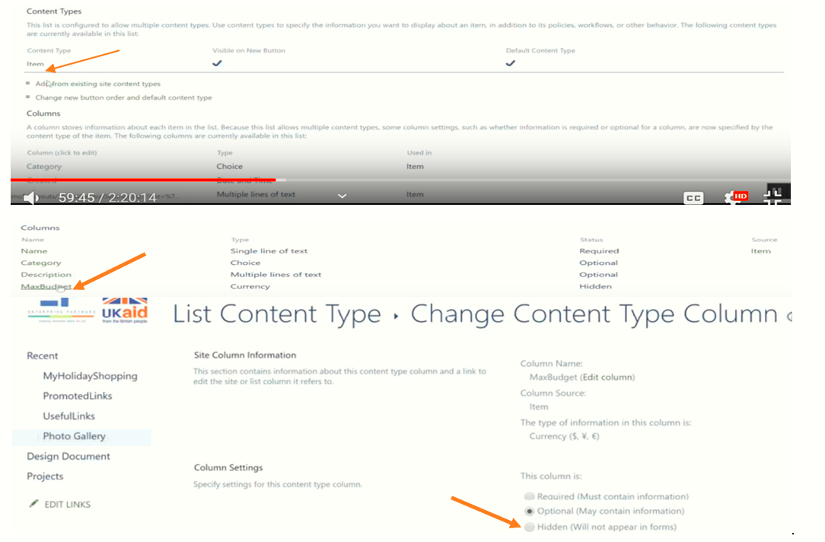

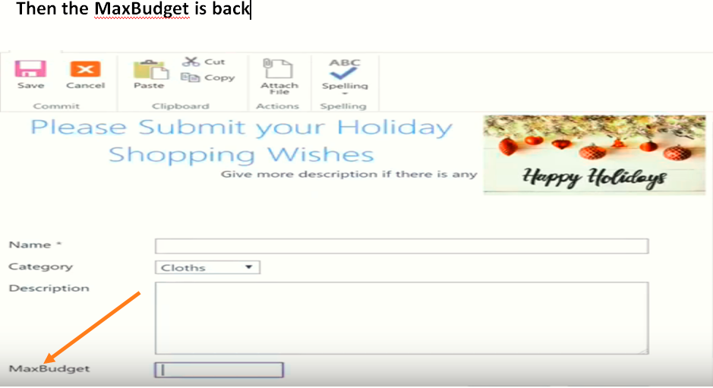 tt

**Calendar**

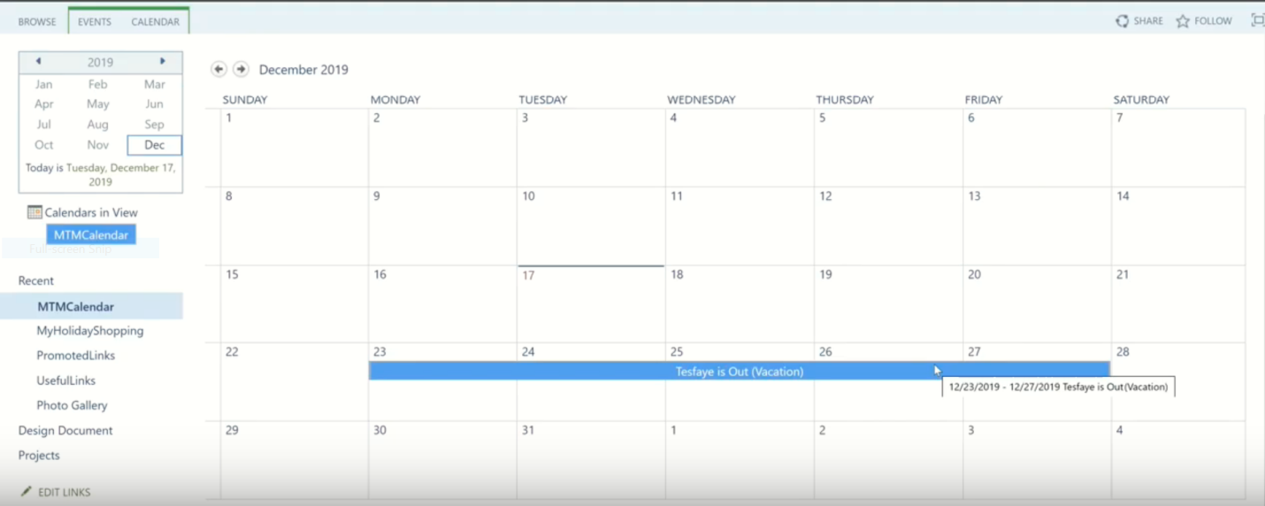

Permission**:**

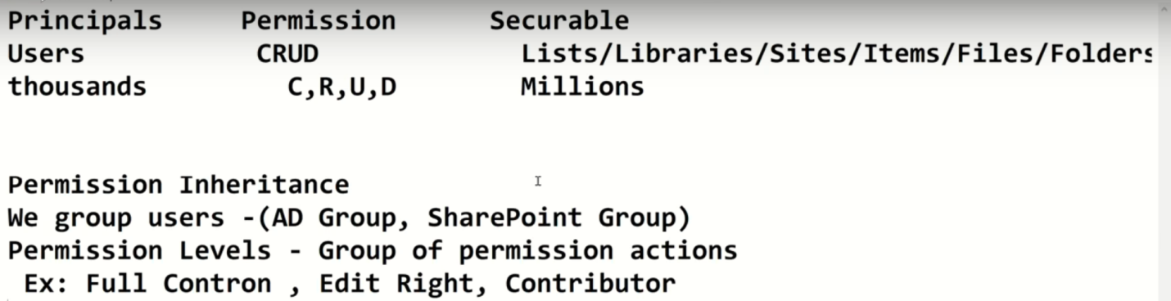

**1:24:58**

**From Home:**

**Setting => site setting =>**

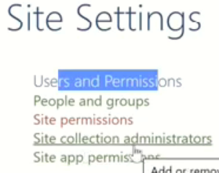

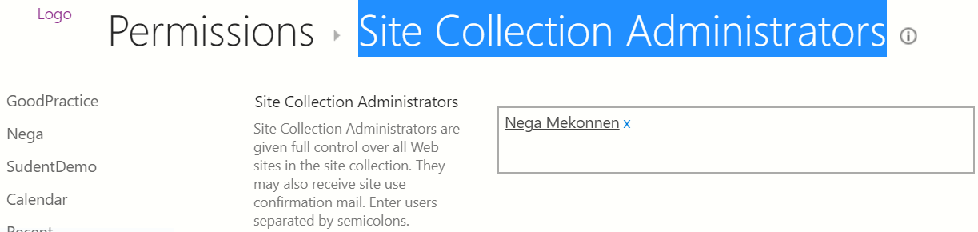

Grant Permission **is use to give permissions for the other**

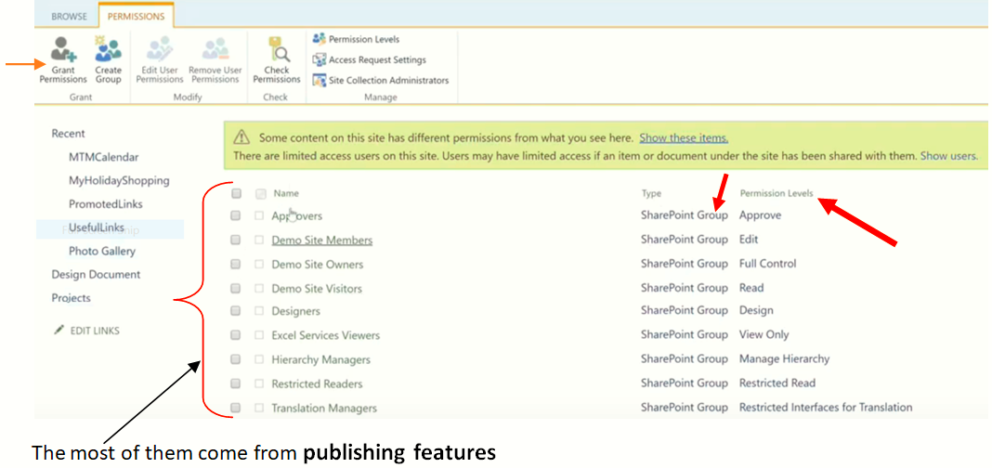

The most of them come from **publishing features**

**Grant**

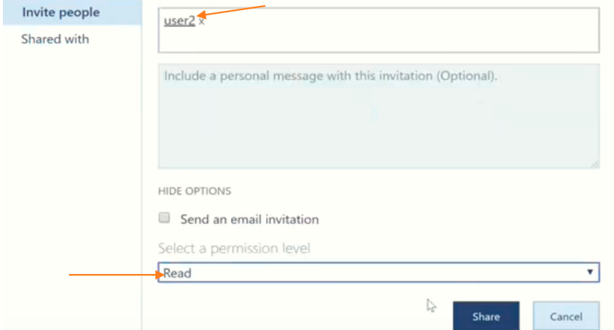

**Then we get**

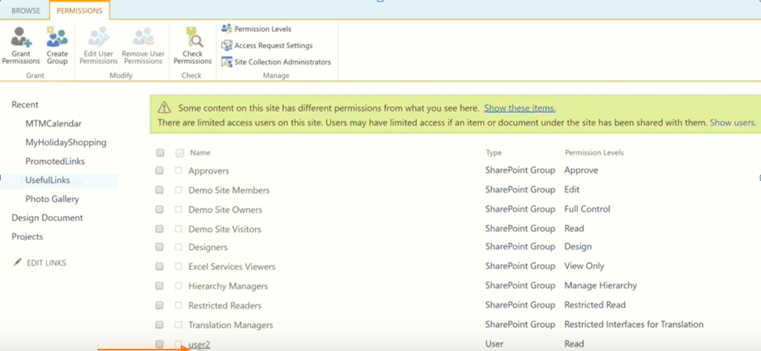

**If we want to delete: select it then remove it.**

Permission Levels**:**

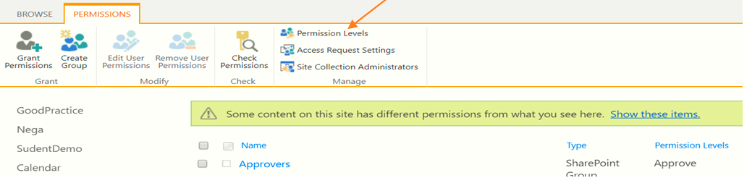

**Then we get the following result. Read the descriptions.**

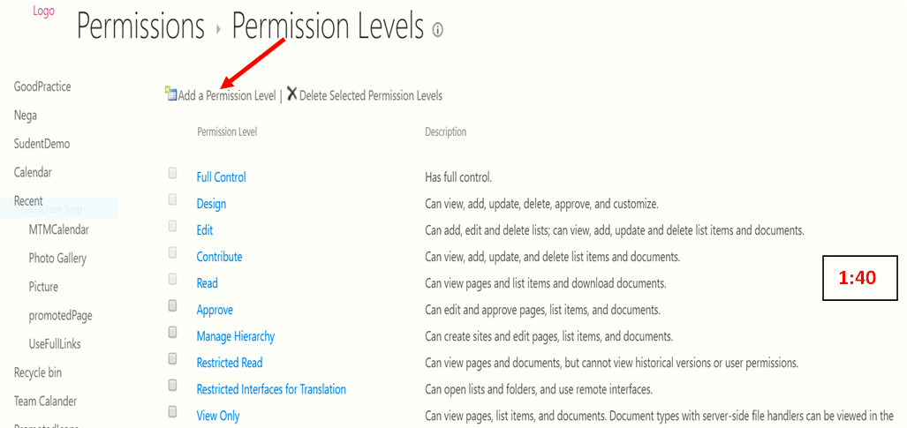

**We get: Create Edit View**

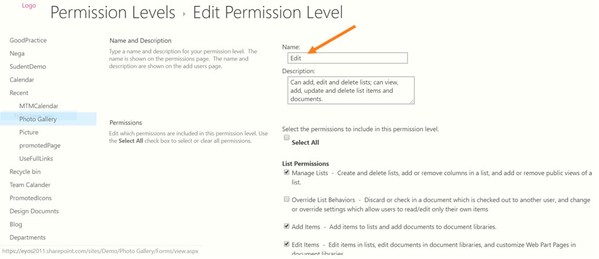

**Ex: create Contribute No delete**

**First create contribute => copy permission Levels =>Then No delete items and no delete views**

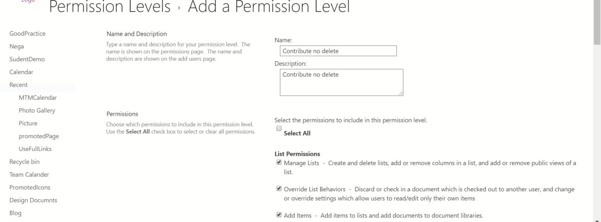

**Create User:**

**Case 1: Chrome => office => Admin =>User => Active user => add user** 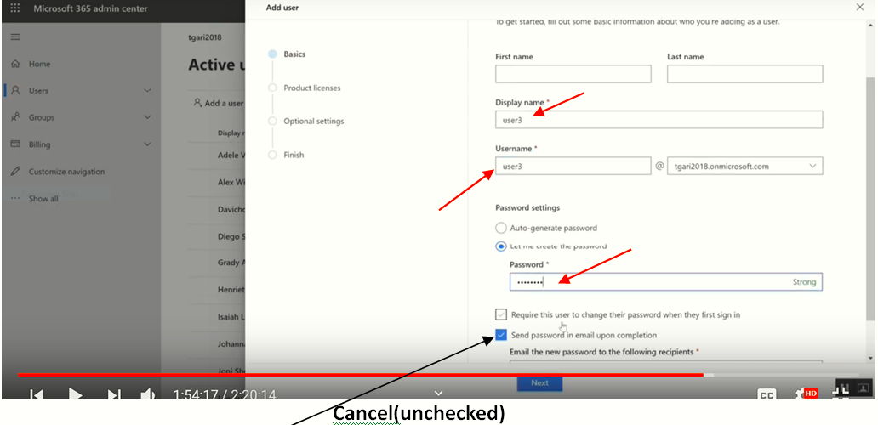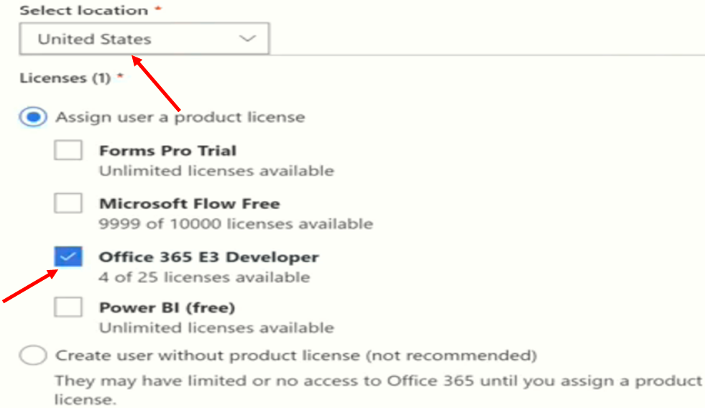

**Case 2: (Tesf): Go to Home page =>right click on SP => Open New tab=>wafl menu =>Admin**

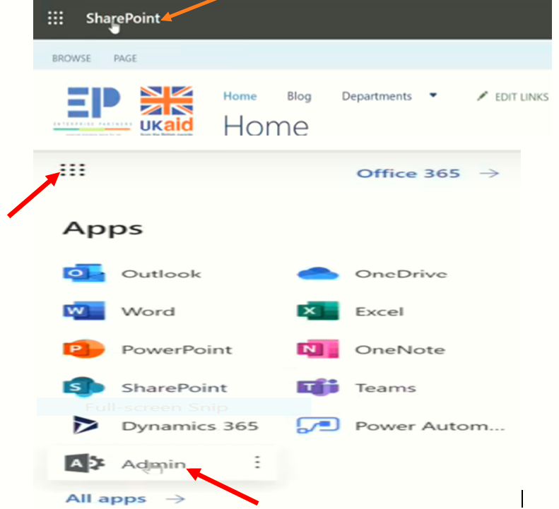

**We landed**

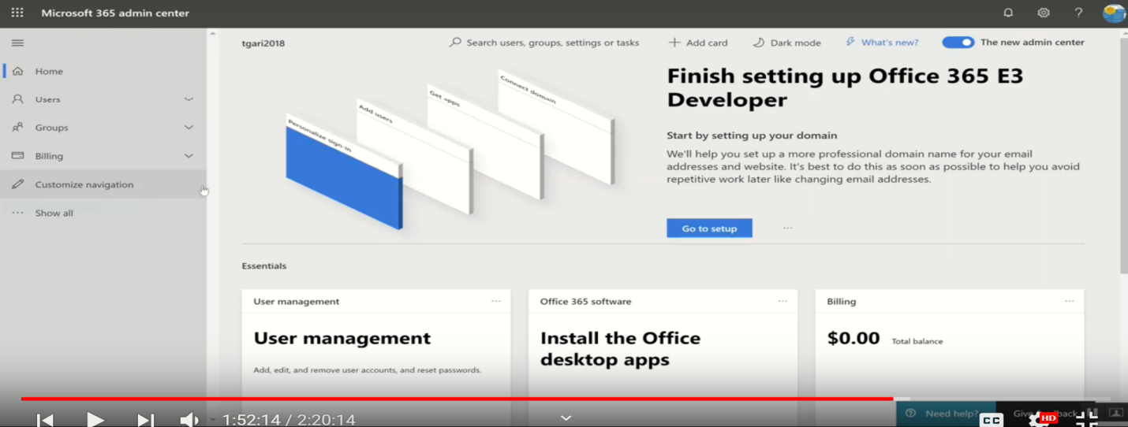

**Users => Active users =>**

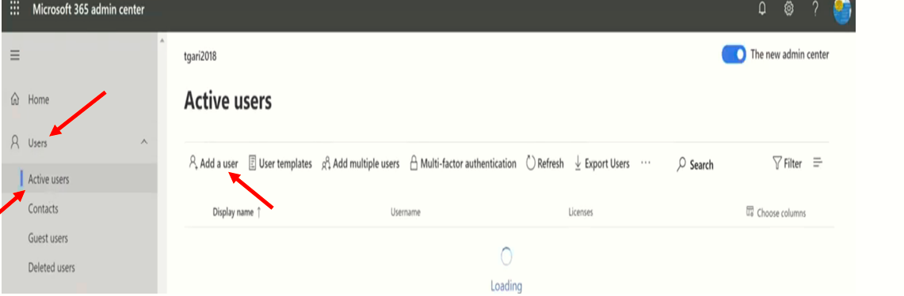

**Click Add a user**

** **

**Then Finish.**

**And then Go to Site Setting =>Site Permission =>**

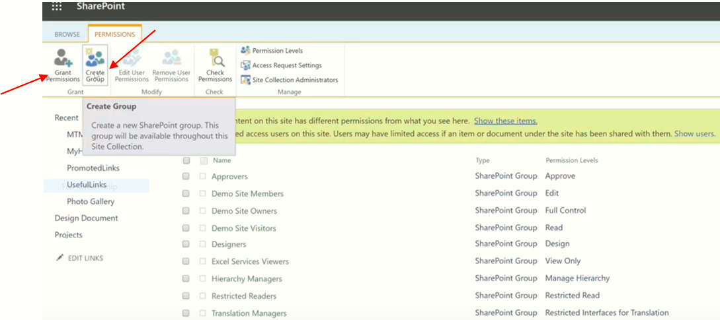

By using **Grant Permission** we can check User3 is existed

By using **Create Group** =>we create (Contribute no delete group) => we get the result

And

Site setting => site permission

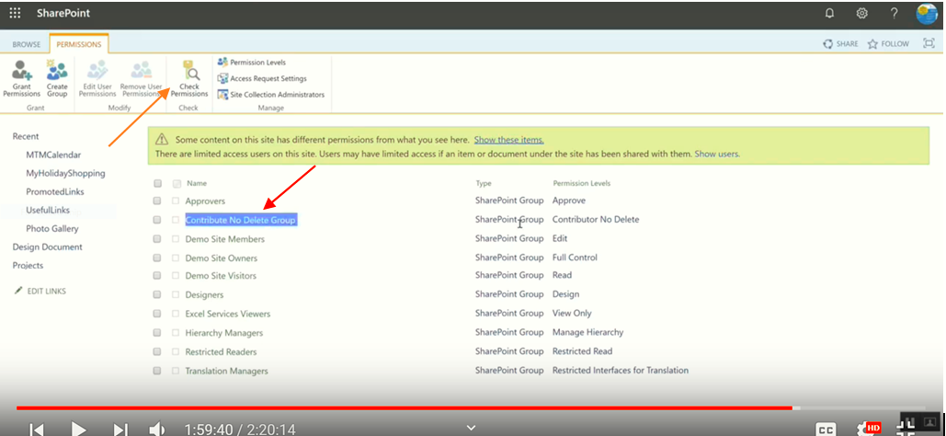

By using Checking permission like the following

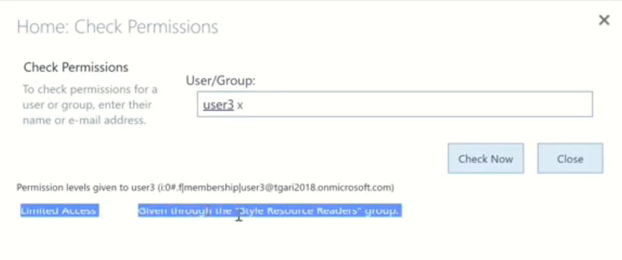

Then how to give the permission

Go to Grant permission =>

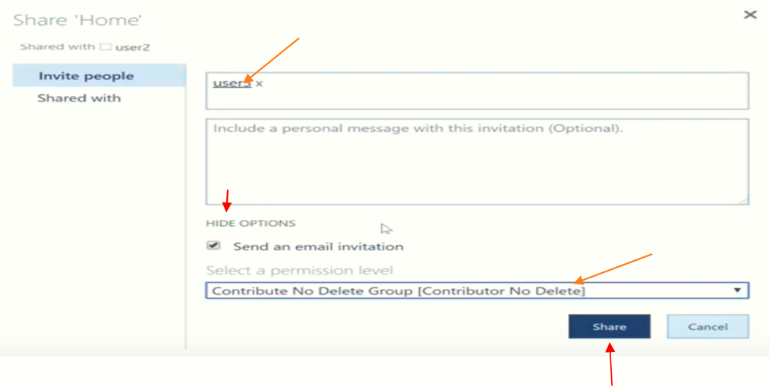**Then by clicking Contribute no delete group =>**

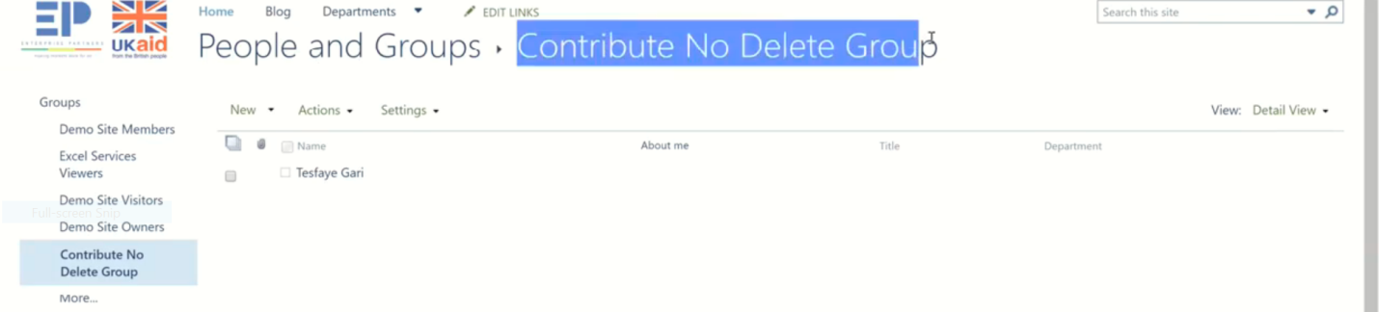

**In this user we can add a new user**

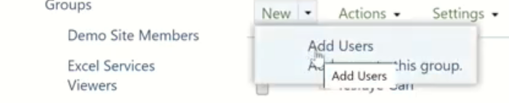

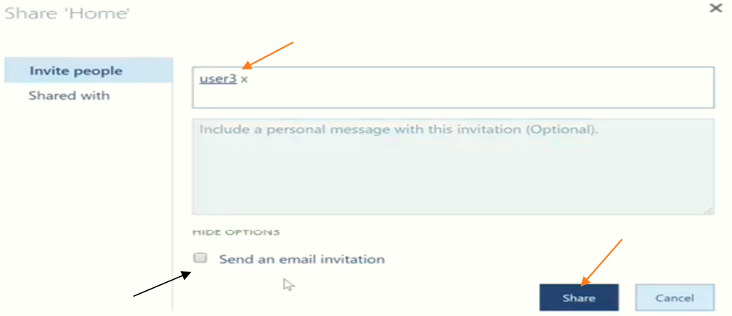

**Unchecked email invitation for the closest person**

**Check Permission again**

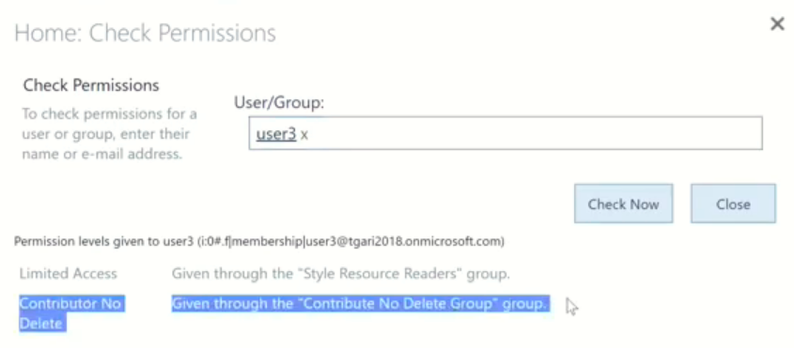

**In New chrome**

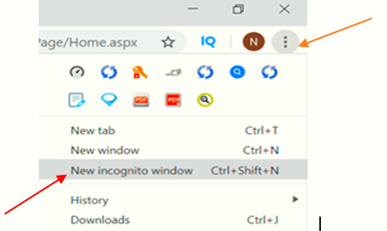

**To check: the user is added**

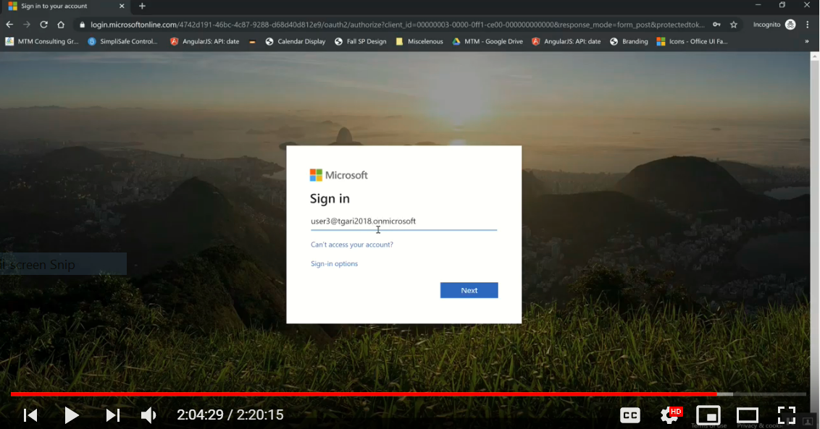

**Put the Password => key , then the new user is apeared. And by using User3 open Holiday Shopping**

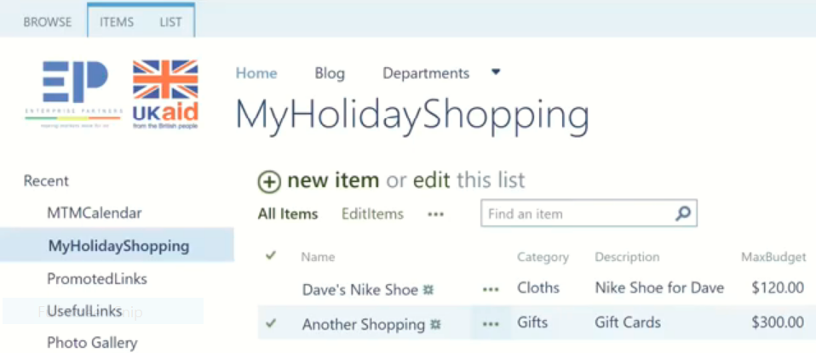

**Under List Check delete is disable**

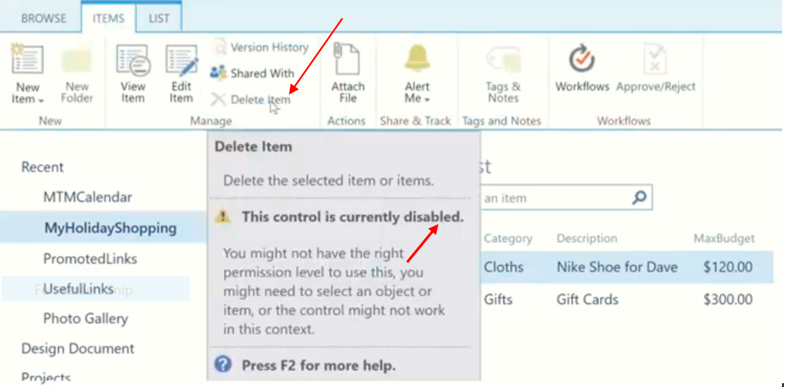

**Disable delete is our Gol.**

**So We can Edit the of an item but not delete**

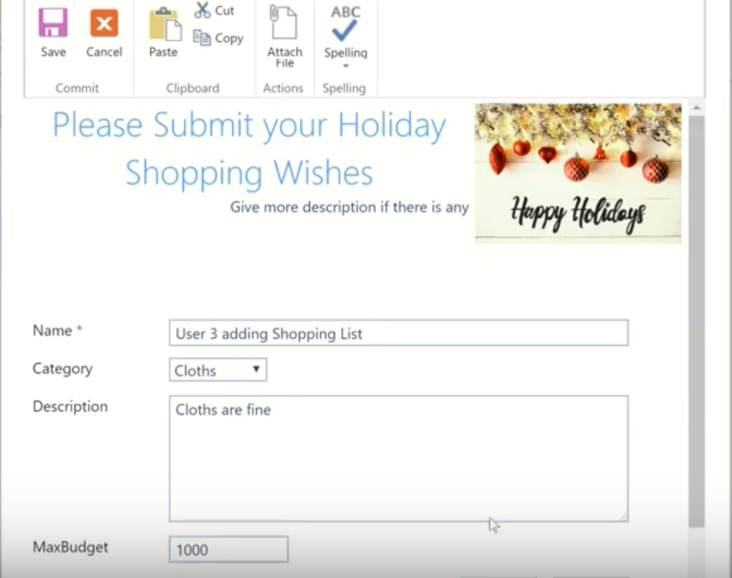

**Special Permission/Stop Inheritance permission**

**Go to the blog: from the user who has full control and check the user who has no full control in that user there is not site setting.**

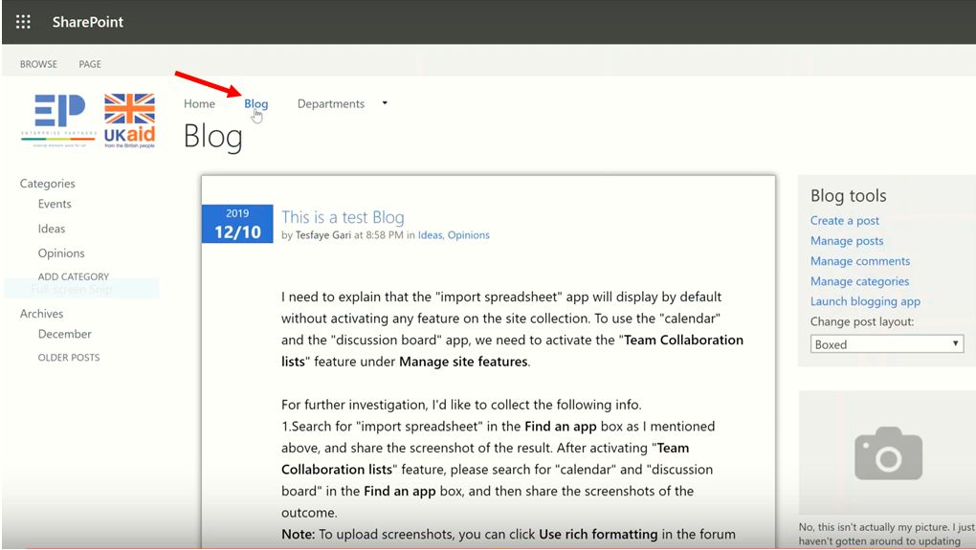

**Site setting => site permission on the user who has full control create key to control user3**

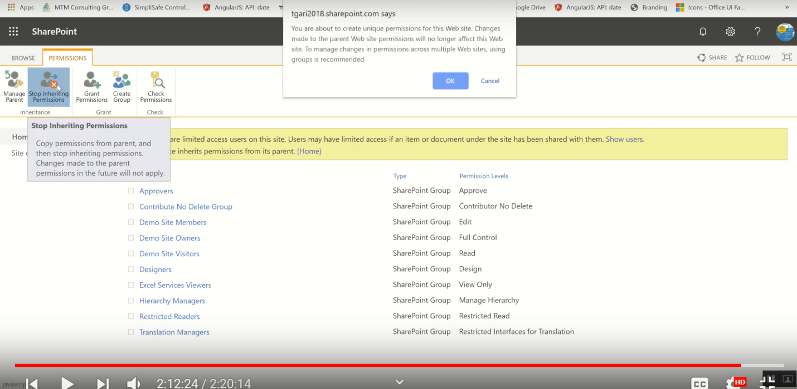

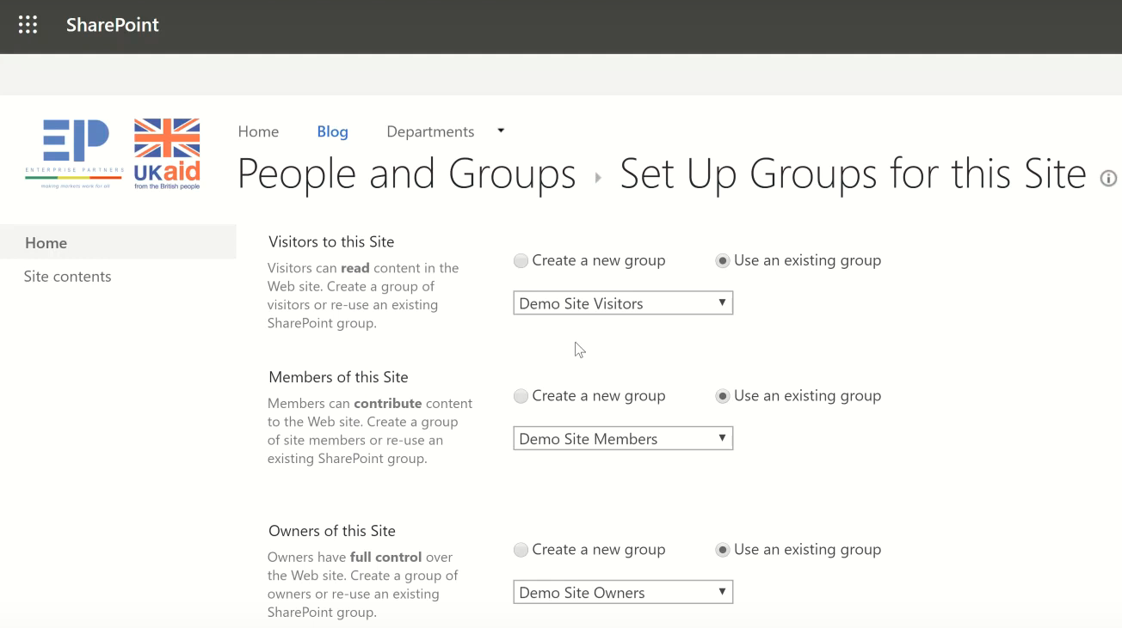

**Then we get the following from that inheritance is deleted**

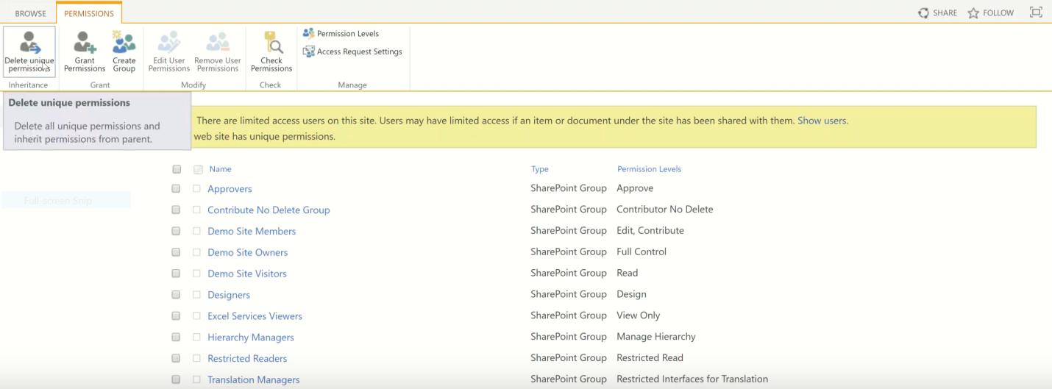

**Can we back deleted inheritance? Yes**

**Site setting => site permission**

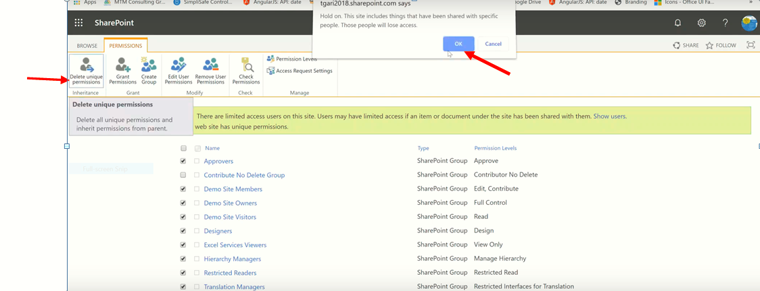

**We do to have user3 is Edit permission:**

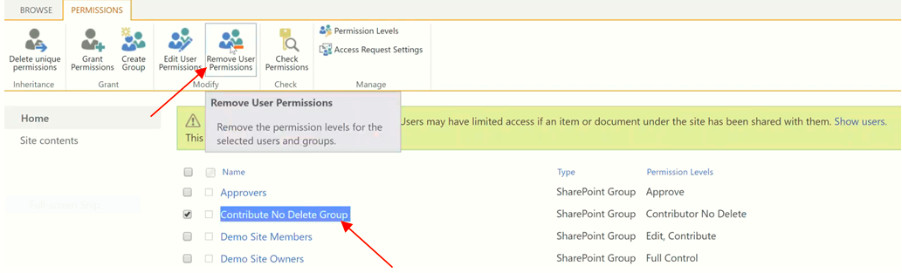

**Blog cant accesses the permission this site.**

**Then it back again.**

If we go to site content andubsite we see only **Departments**

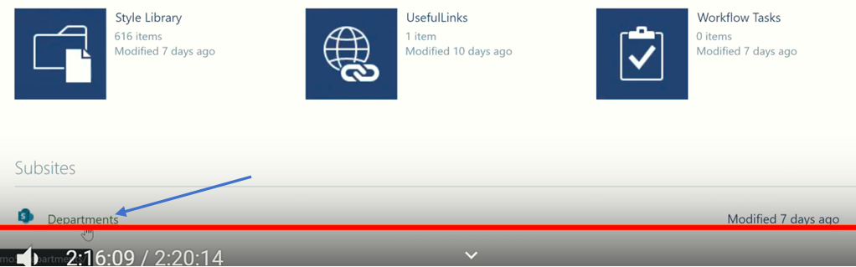

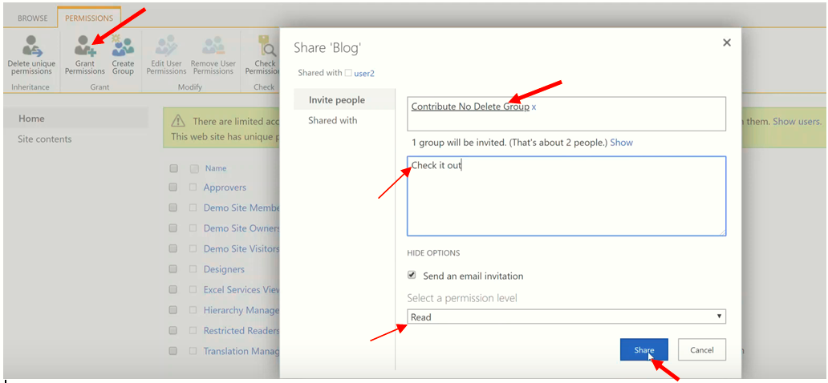

And then we get email Notification to go Blog

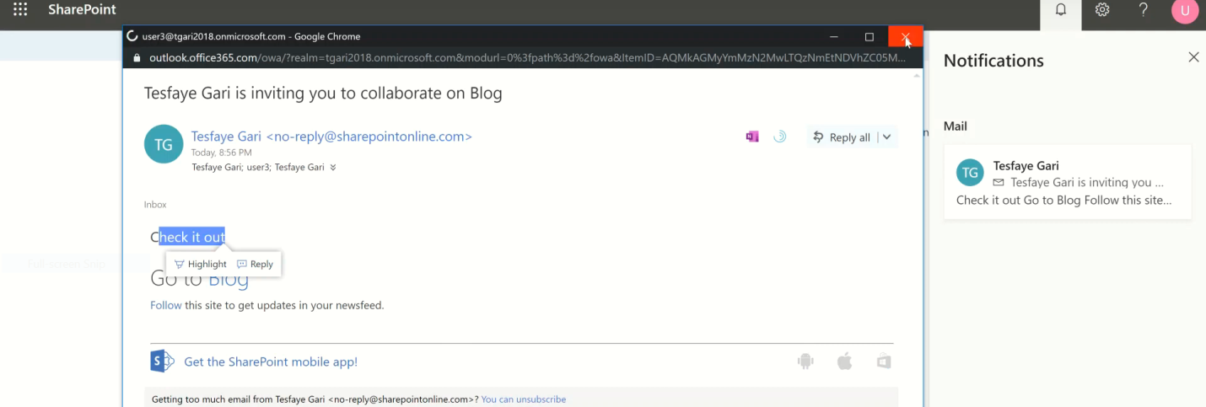

When we go to home page we get Blog but it is not real b/se some contents are missing

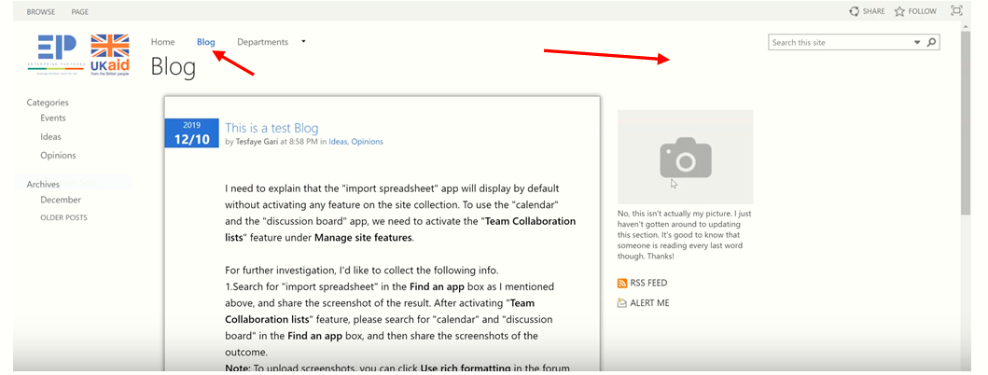

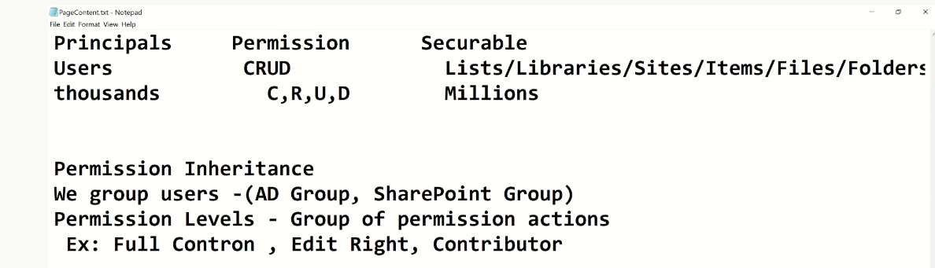

# Summary for permition

1. **Create** Permission, **Group** Permission, **Add user to** Permission Level, **check user, either it exist permission level or no** and **check our goal on new browser**

**Create Permission:**

Setting =>Site setting =>Site permission

Permission Level => Open contribute =>Copy permission Level => write Contribute no delete =>Uncheck (delete item and delete version) => create

**Group Permission:**

Group Permission => write Contribute no delete =>check “Contribute no delete” at bottom =>ok

**Add user:**

Contribute no delete =>New => Write user =>ok

Or

Grant permission =>Write user => drop down at the bottom => select permission

**End of class 10**